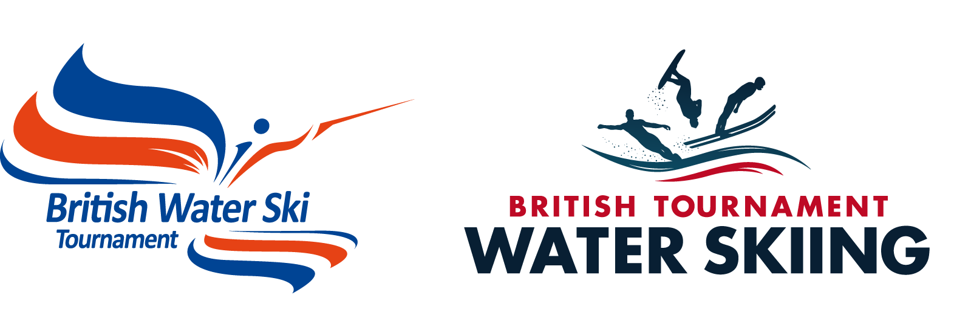

THE 2019 BRITISH TOURNAMENT OFFICIALS SEMINAR Saturday 4th May 2019

Dear Officials and Tournament colleagues,

We do hope you will be attending our one day British Tournament Officials Seminar on Saturday the 4th May 2019, starting at 10.00am. This year we are holding the seminar at The Bentley Hotel, Newark Road, South Hykeham, Lincoln, LN6 9NH. There are plenty of hotels nearby for those wanting to stay and the three listed below are the best options. We have a deal with the Bentley with a double room at £95 and a single at £85. Just quote BWSW Seminar on booking.

Ibis - 01522 698333 Bentley - 01522 878000 Travelodge - 08719 846085

British Water Ski & Wakeboard HQ. staff and the Tournament and Technical Committee’s give a large slice of time, finance and effort in putting this seminar together to continue our investment in the high standard of our officials and to offer interested newcomers the opportunity to meet other Officials and become more involved in the sport. Please find enclosed a programme for Saturday, and a seminar booking form. Please email the completed form back to gvnkelly@aol.com as soon as possible so that we can finalise arrangements with the hotel.

As stated in our British Additional Rules, officials must attend our British Officials Seminar at least once every three years in order to retain their qualification and be considered for inclusion in a National panel. In addition this year we will facilitate a J2 (Senior Judge) three year retest and a J2 (Senior Judge) 2/3 event exam, more details to follow.

With the continual increase in the use of technology in the sport it is important that all Judges are familiar with its operation and Ian Collins will as usual have the various video timing and Jump measurement systems available for explanations and hands on practise.There will be trick reading practise at both beginner and advanced levels and guidance for anyone wishing to learn the art of Scoring.

Also there will be experienced drivers on hand to help any drivers wanting Jump driving experience or to be assessed on their Jump Driving skills. This will take place at Hazelwoods during the afternoon.

PLEASE make every effort to attend - you can see the programme has something to offer for every category, it is very informative and the seminar is a fun social event with a chance to meet others involved in the sport. There will be refreshments provided. Please complete the booking form so we have some idea on seating and food numbers and send it off now!

On Sunday 5th and Monday 6th May we have the first 2 day tournament of 2019, this will be slalom and trick only, taking place at Hazelwoods Ski World. This is an opportunity for new judges and calculators to practice alongside the panel. There is also an opportunity for any National 1 drivers If you would like some early season practise, please indicate on the seminar attendance form, if you wish to be considered.

We really look forward to seeing you at our Seminar and offer our thanks in anticipation for your help in the coming season.

Best regards,

Gavin - Chair Tournament Working Group

February 2019

BRITISH OFFICALS SEMINAR 2019

Saturday 4th May 2019

Programme

10.00 Start

- Welcome and introductions by Steve Sopp Chairman of the Tournament Committee

- Toutech - A new approach - Gavin Kelly

- A résumé of the changes to the Rules at IWWF and European Level & British - Gavin Kelly

- E&A Update - Nigel Talamo

- Handicap League - A new focus - Catherine Wharton

- Driver Upgrades - New structure and pathway – Mark Burridge

- FoT 200 Club April Draw

Lunch

At this point in the proceedings officials will disperse to their own groups.

- Judges Discussion of any changes to rules. Trick reading practise in groups.

- Drivers- Review of any issues bought up at the E&A seminar, on water discussions and jump driving experience and driver upgrade pathway

- Technical Corner - Practical use and explanation of Splash Eye (and other systems) for Trick Timing and End Course for ALL judges and Calculators in small Groups throughout the day

- Special Groups for Instruction and Tuition:-

  - Scoring Paul Airey/Catherine Wharton
  - Trick Reading Jill Howard/Gavin Kelly
  - Homologation Nigel Talamo
  - Drivers Mark Burridge
  - New Judge Training Barry Odell
  - Dealing with Tech Ian/Richard

- Upgrade and retest exams in Syndicate Room

- Interactive Quiz

- Final General Discussion and Close of Seminar.

Finish About 4.00 -4.30

