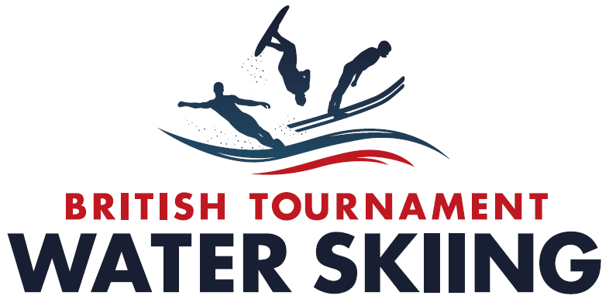

**Magazine Article June 2018**

**Friends of Tournament -200 Club Update**

At the Tournament Ball in November 2016 we launched the Friends of Tournament Group whose aim was to support fund raising to assist our elite skiers to attend European and World Championships as well as promoting initiatives to help the continued development of Tournament Waterskiing.

The first initiative was to launch a 200 Club Lottery that started in January 2017 with 35 ticket holders. We have seen steady growth in participation and in the June 2018 draw there are 92 ticket holders.

The monthly Lottery Ticket price is £25 of which 32.5% goes towards prizes and the rest is building our fund. There are three prizes every month with a prize double up month in November each year. So in June the prizes will be, £345, £230, and £115.

The odds on getting a win are really good and the 48 prizes drawn till April 2018 have gone to 36 different winners with one lucky ticket holder winning four times, one three times, seven two times and twenty seven winning once.

In 2017 the 200 Club and a couple of other small fund raising initiatives raised a total of £17,730 of which £5,550 was paid out to 22 skiers towards Team Travel. As a result £8,180 was carried forward into 2018. Based on the current 92 ticket holders we will raise a further £17,615 in 2018 but hopefully we will reach our target of at least 100 and so will raise more than this.

In 2018 we anticipate paying out £9,000 towards Team Travel and a further £5,450 to support six development days and three days of Squad training that will take place in August at South Lake with Damien Ackerer. The Development Days have been completed at six different sites and with funding from BWSW and Friends of Tournament these were attended by 36 young skiers who received coaching from Mick Hazelwood, Rob Hazelwood, Ben Turp, Nick McGarry and others. The participants will get a free Tournament Licence and be encouraged to give competitions a try.

With the loss of funding from UK Sport and the ongoing reduction of funding from Sport England this fund raising is of vital importance to encourage new skiers into competitive Tournament skiing and to ensure we are able to send our very best teams to represent us in Europe and the World. So please join us as a Friend of Tournament and a 200 Club Lottery ticket holder.

Details and sign up forms can be found by using the links in the 200 Club news item on the BWSW website.

Gavin Kelly

June 2018